Uge 39 Challenge

Case Study: Selection
Java programming project, you will develop a simple program.
In this Java project, you will create a program that takes a Danish grade (from the 7-point grading scale) as input and converts it to the American letter grade scale (A, B, C, D, F). The purpose is to practice using if-else statements in Java. The goal is to practice using selection structures.

User Input
- The program should ask the user to enter a numerical grade (e.g., a test score) as input.

Example Output
Welcome to the Student Grade Calculator!
Enter the student's Danish grade: 7
The student's grade in the USA is: C

Reference
Danish 7-point grading scale | American letter grade
12 | A
10 | B
7 | C
4 | D
02 | E
00 or -3 | F

Case Study: Iterations Checking Palindromes

A string is a palindrome if it reads the same forward and backward. The words “mom,” “dad,” and “noon,” for instance, are all palindromes.
think before you code
The problem is to write a program that prompts the user to enter a string and reports whether the string is a palindrome. One solution is to check whether the first character in the string is the same as the last character. If so, check whether the second character is the same as the second-to-last character. This process continues until a mismatch is found or all the characters in the string are checked, except for the middle character if the string has an odd number of characters.
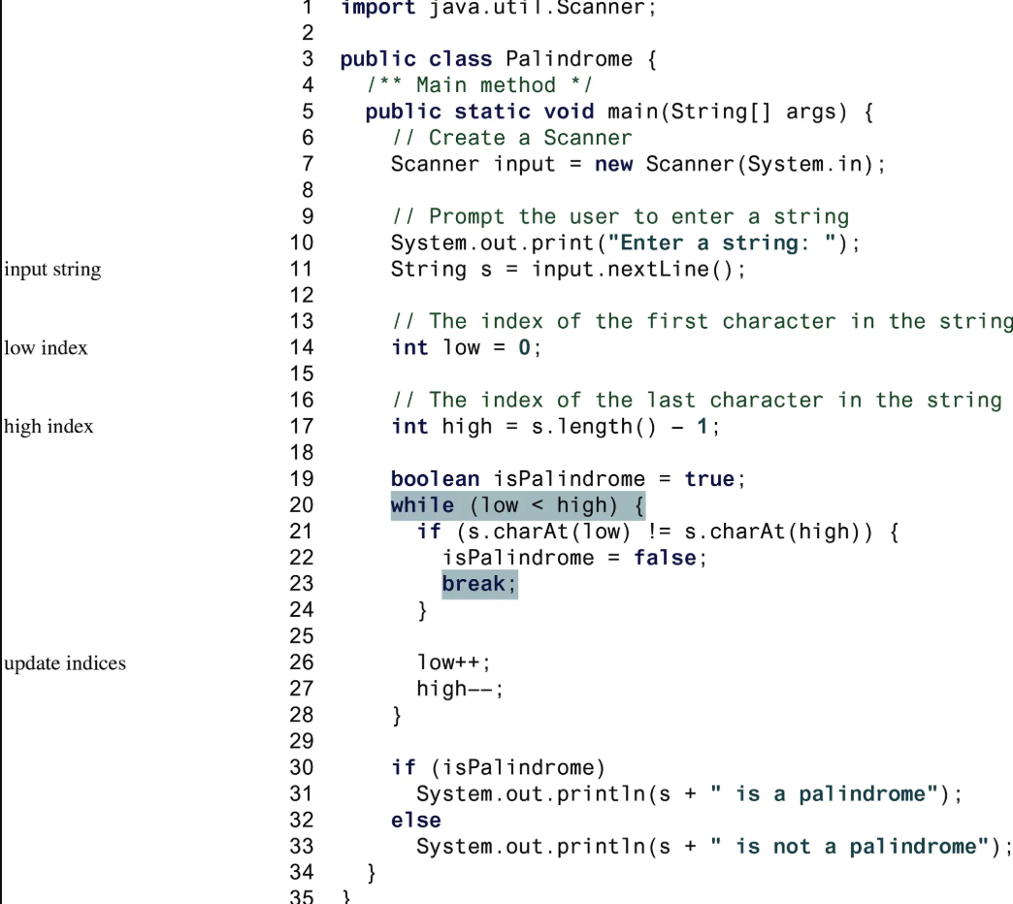
Hint

https://www.codecademy.com/courses/learn-java/lessons/java-string-methods/exercises/charat

